DAY 1

-> Use ord() function to get the ascii value of any character

->
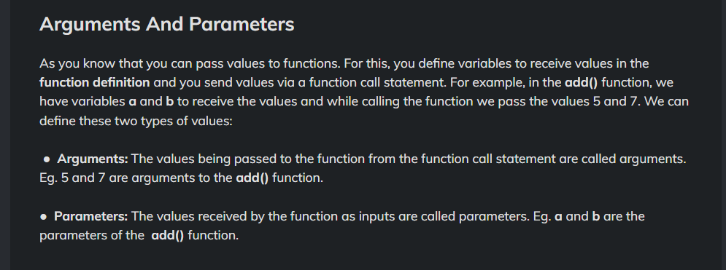

->To deal with function overloading – cause python won’t support function overloading natively as other programming languages

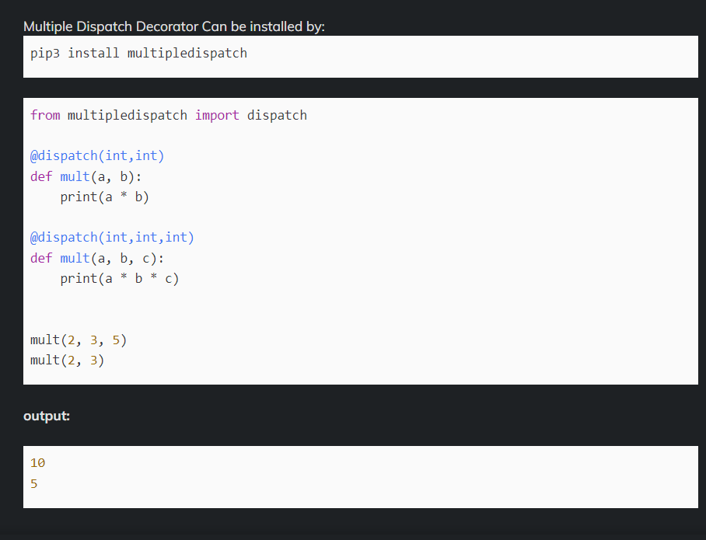
-> variable length Arguments

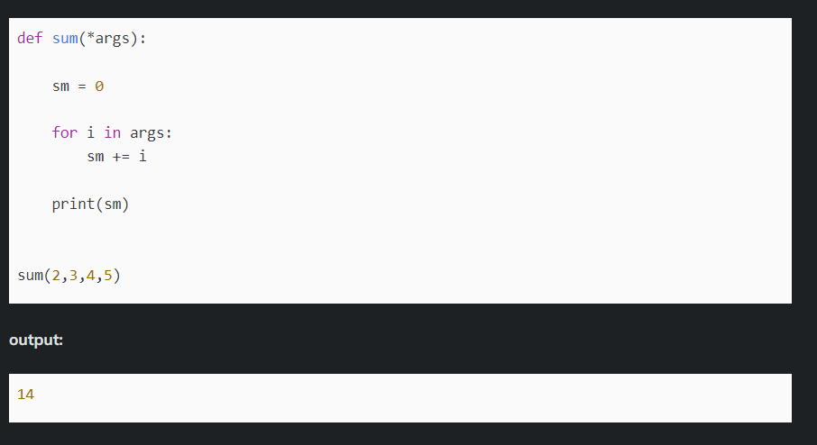

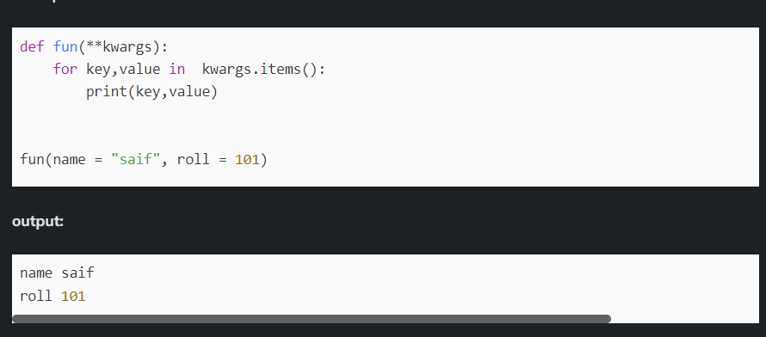

->Basic functions
--->round()
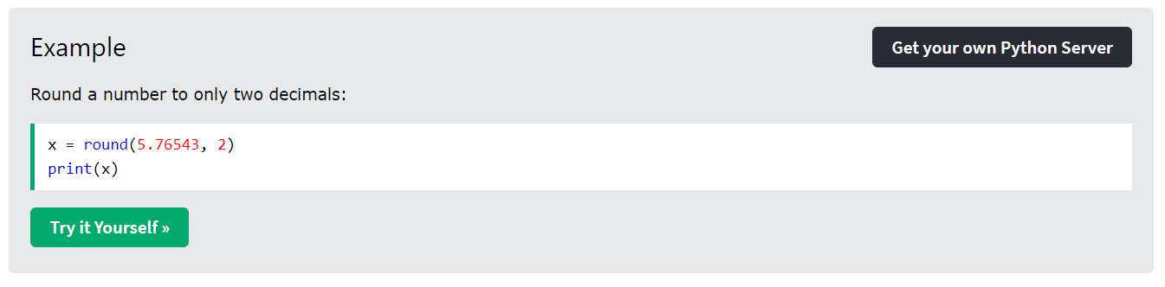

--->abs()
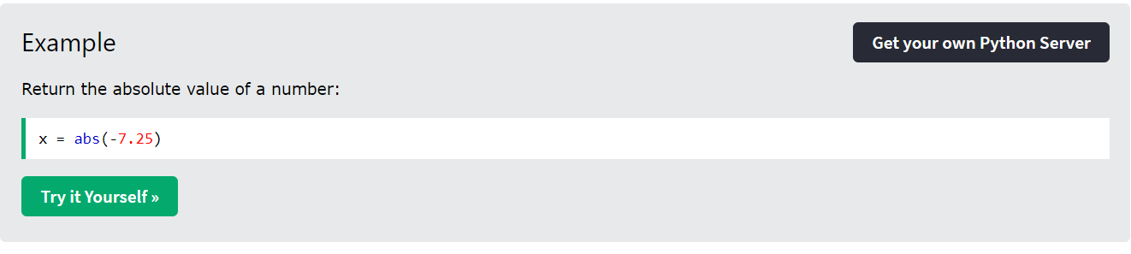
...much more

->List Methods:
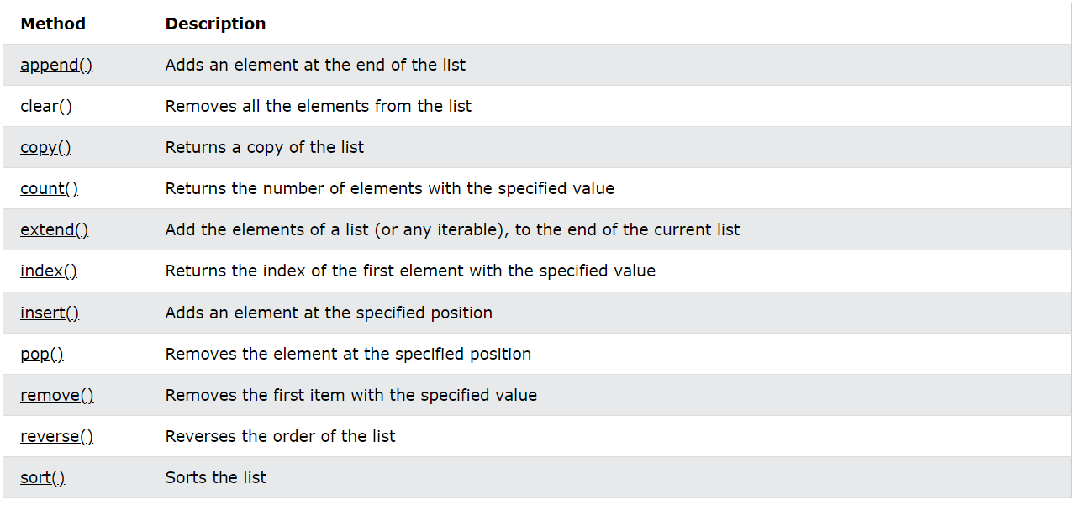

->Python doesn’t support switch casing like other languages

->Python’s argument passing model is neither “Pass by Value” nor “Pass by Reference” but it is “Pass by Object Reference”.
OR
->The unique difference between pass by value for primitive and immutable data in python and pass by reference for mutable data types is called pass by assignment
https://www.youtube.com/watch?v=otWHB_IEeHI

->can’t perform len() function on integers
TIME COMPLEXITY:

-> Time complexity is not equal to the time taken by the machine to execute the program rather its the rate at which the time taken increases with respect to the input size

-> Consider Worst TC

SPACE COMPLEXITY:
-> Auxillary space – Space that takes to solve the problem
->Input Space - Space that takes to store the Input
->Never manipulate the data itself (coding interview tip)

